Name:____________________________________________

Animal Cell Colouring
Cell Membrane (light brown) |  | Nucleolus (black) | Mitochondria (orange)
Cytoplasm (white) |  | Golgi Apparatus (pink) | Lysosome (purple)
Nucleoplasm (pink) |  | Cilia (yellow) | Microtubules (green)
Nuclear Membrane(dark brown) |  | Rough Endoplasmic Reticulum (dark blue)
Ribosome (red) | Smooth Endoplasmic Reticulum( light blue)

Briefly describe the function of the cell parts.
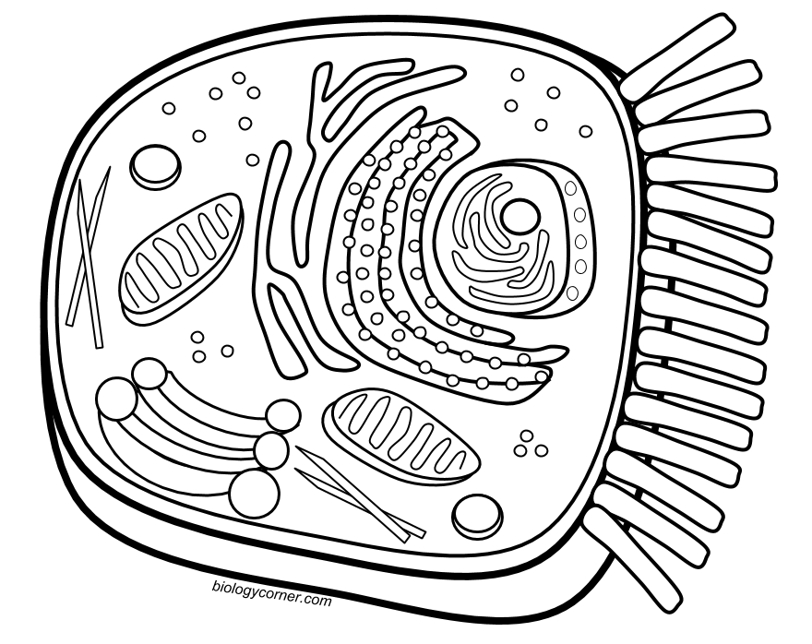
- Cell membrane ________________________________________________________________________________________________
2. Endoplasmic Reticulum ________________________________________________________________________________________________
3. Ribosome ________________________________________________________________________________________________
4. Golgi Apparatus ________________________________________________________________________________________________
5. Lysosome ________________________________________________________________________________________________
6. Microtubule ________________________________________________________________________________________________
7. Mitochondria ________________________________________________________________________________________________
8. Nucleus _______________________________________

